**Practical No. 9**

**Title: Using AWS Flow Framework develop application that includes a simple workflow.**

**Workflow calls an activity to print hello world to the console. It must define the basic**

**usage of AWS Flow Framework, including defining contracts, implementation of**

**activities and workflow coordination logic and worker programs to host them**

1. **Procedure:**

Security using MFA(Multi Factor Authentication) device code:

1) goto aws.amazon.com

2) click on "My Account"

3) select "AWS management console" and click on it

4) Give Email id in the required field

if you are registering first time then select "I am a new user" radio button

5) click on "sign in using our secure server" button

6) follow the instruction and complete the formalities

(Note: do not provide any credit card details or bank details)

sign out from

7) Again go to "My Account"

select "AWS management console" and click on it

Sign in again by entering the user name and valid password ( check "I am returning user and my password is" radio button)

Now you are logged in as a Root User

All AWS project can be viewed by you, but you cant make any changes in it or you cant create new thing as you are not paying any charges to amazon (for reason refer step:6)

**To create the user in a root user follow the steps mentioned below:**

1) click on "Identity and Access Management" in security and identity project

2) click in "Users" from dashboard

It will take you to "Create New Users"

click on create new user button

enter the "User Name"

(select "Generate and access key for each user" checkbox, it will create a user with a specific key)

click on "Create" button at right bottom

3) once the user is created click on it

4) go to security credentials tab

5) click on "Create Access Key", it will create an access key for user.

6) click on "Manage MFA device" it will give you one QR code displayed on the screen

you need to scan that QR code on your mobile phone using barcode scanner (install it in mobile phone)you also need to install "Google Authenticator" in your mobile phone to generate the MFA code

7) Google authenticator will keep on generating a new MFA code after every 60 seconds

that code you will have to enter while logging as a user.

Hence, the security is maintained by MFA device code...

one can not use your AWS account even if it may have your user name and password, because MFA code is on your MFA device (mobiel phone in this case) and it is getting changed after every 60 seconds.

**Permissions in user account:**

After creating the user by following above mentioned steps; you can give certain permissions to specific user

1) click on created user

2) goto "Permissions" tab

3) click on "Attach Policy" button

4) select the needed policy from given list and click on apply.

1. **Result:**

Step 1 :goto aws.amazon.com

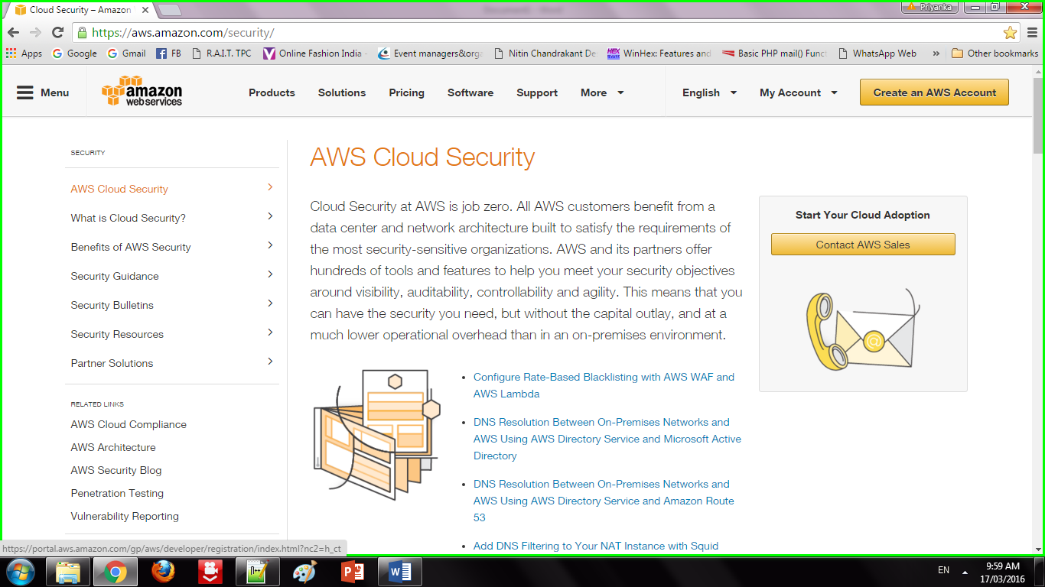

Step 2 : Click on "My Account". Select "AWS management console" and click on it. Give Email id in the required field

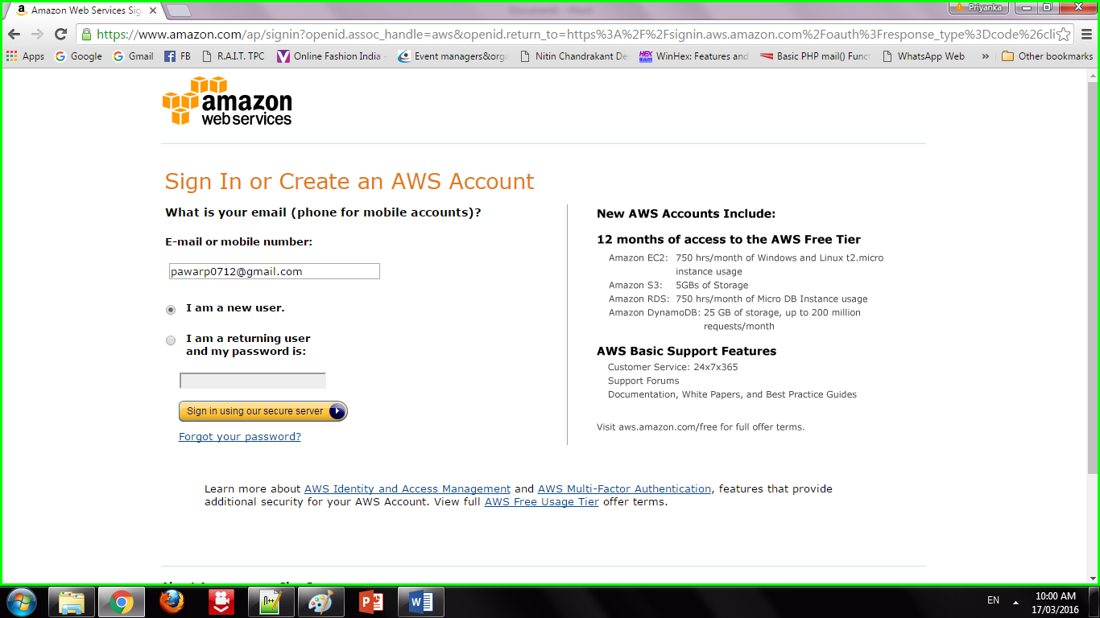

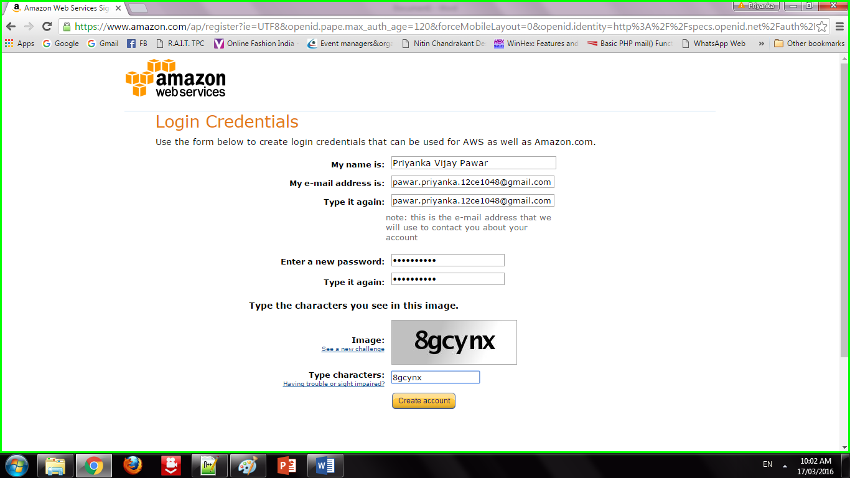

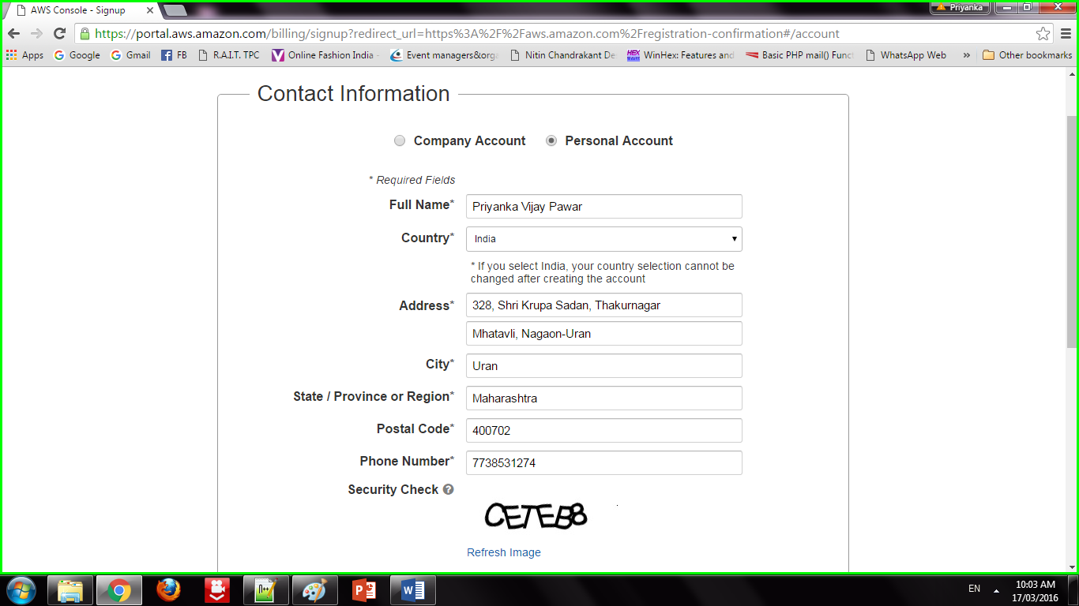

Step 3: Addition of security features

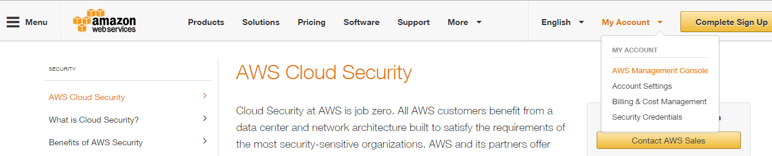

Step 4: Sign in to an AWS account

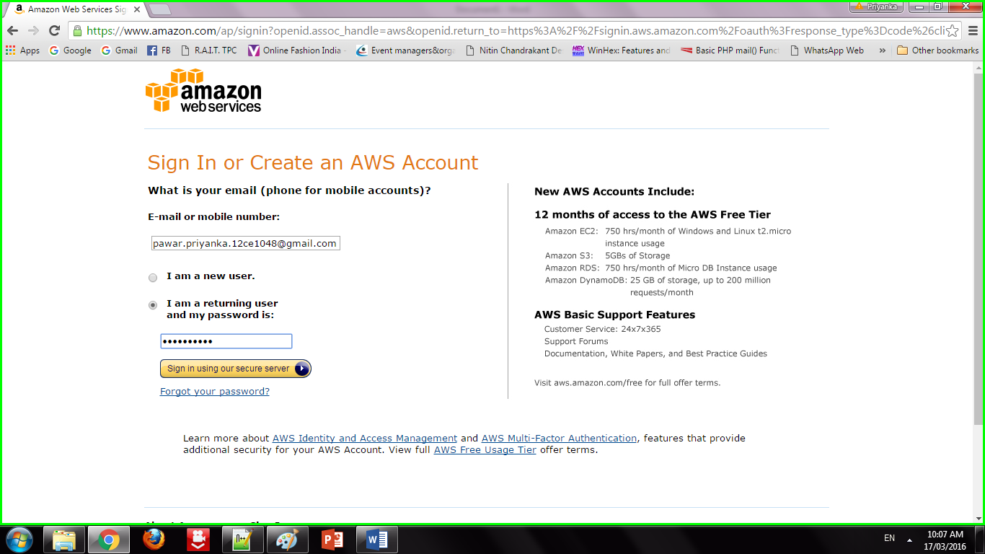

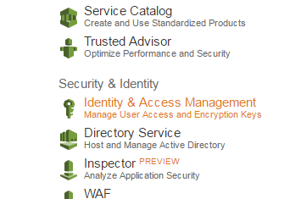

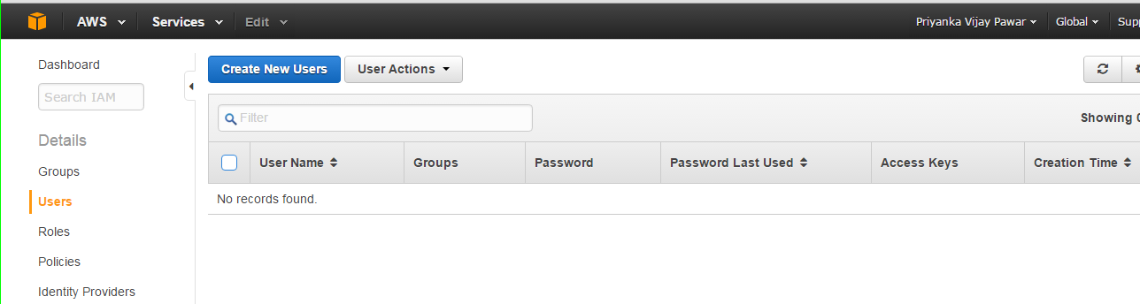

Step 5 : Creation of users

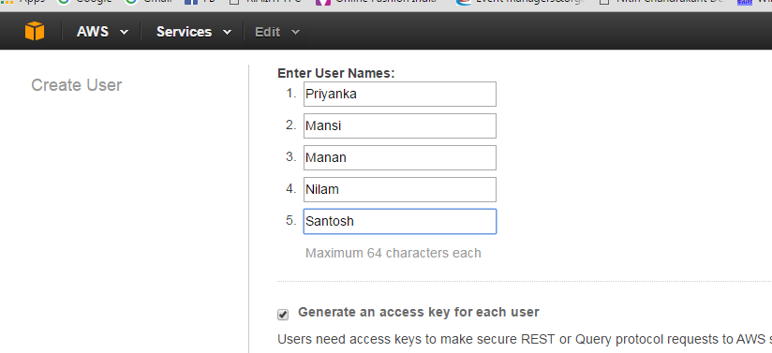

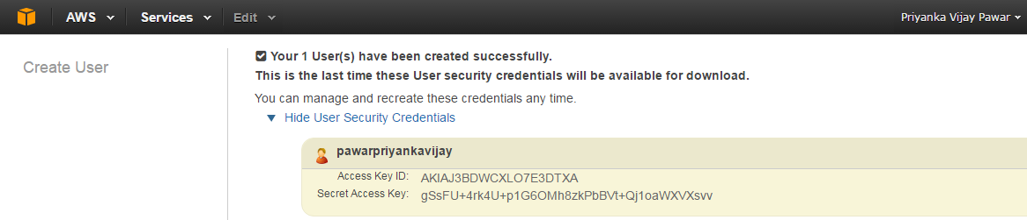

Step 6: Adding users to group

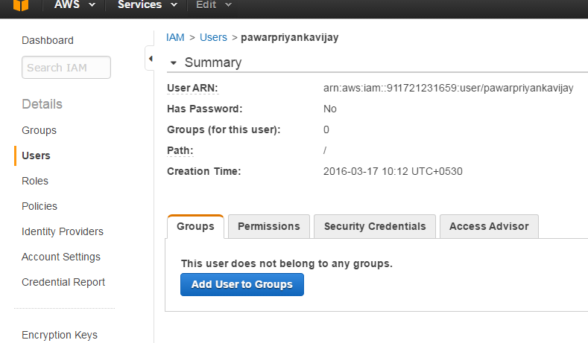

Step 7: Creating Access key

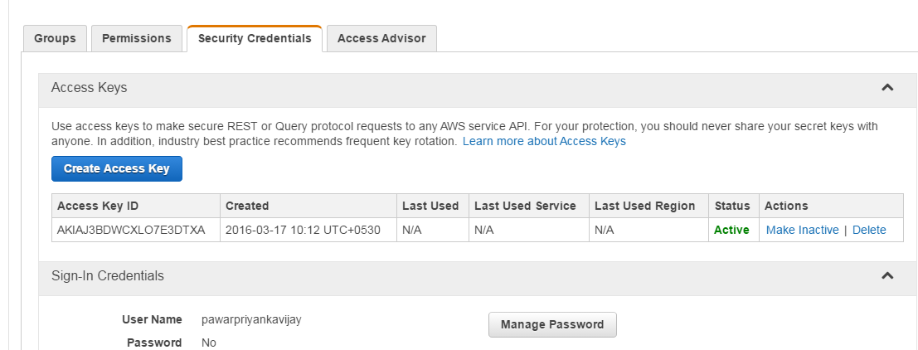

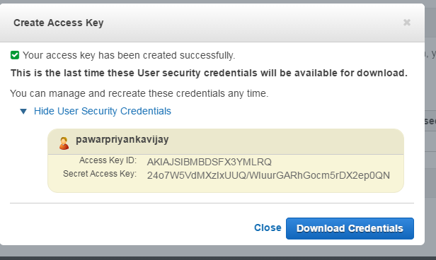

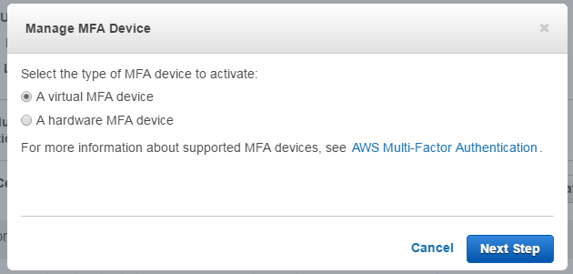

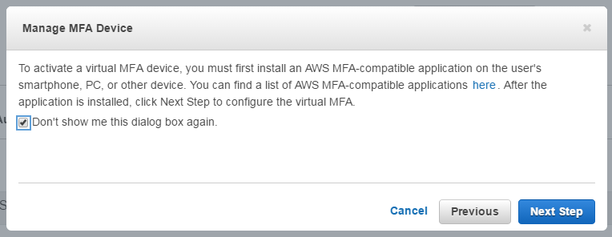

Step 8 : Setting permissions to users

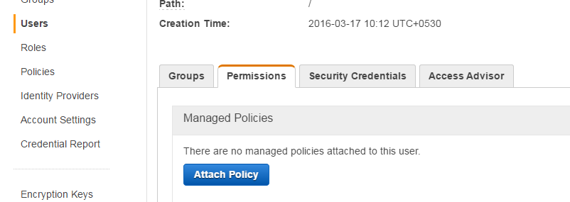

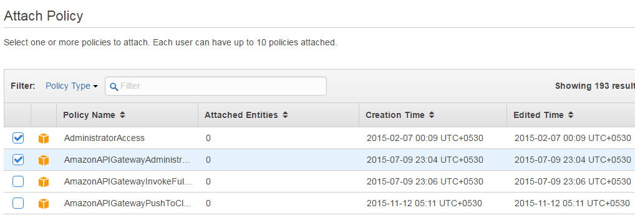

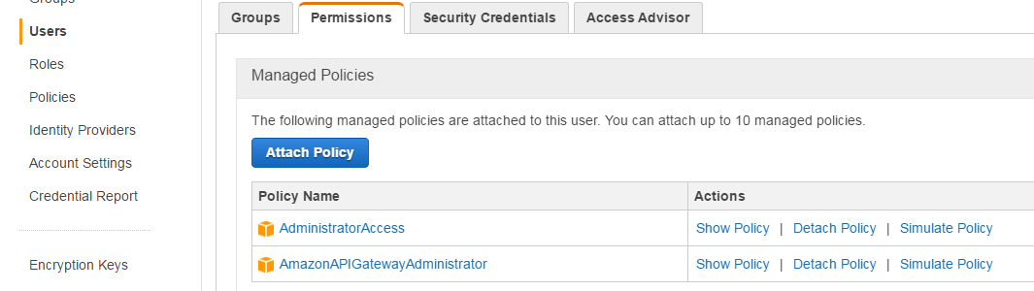

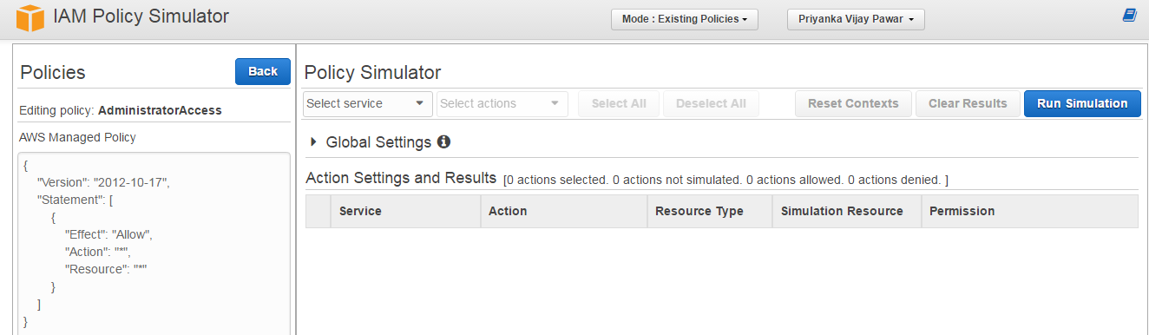

1. **Conclusion:**

We have studied how to secure the cloud and its data. Amazon EWS provides the best security with its extended facilities and services like MFA device. It also gives you the ability to add your own permissions and policies for securing data more encrypted.